# High Level Picture

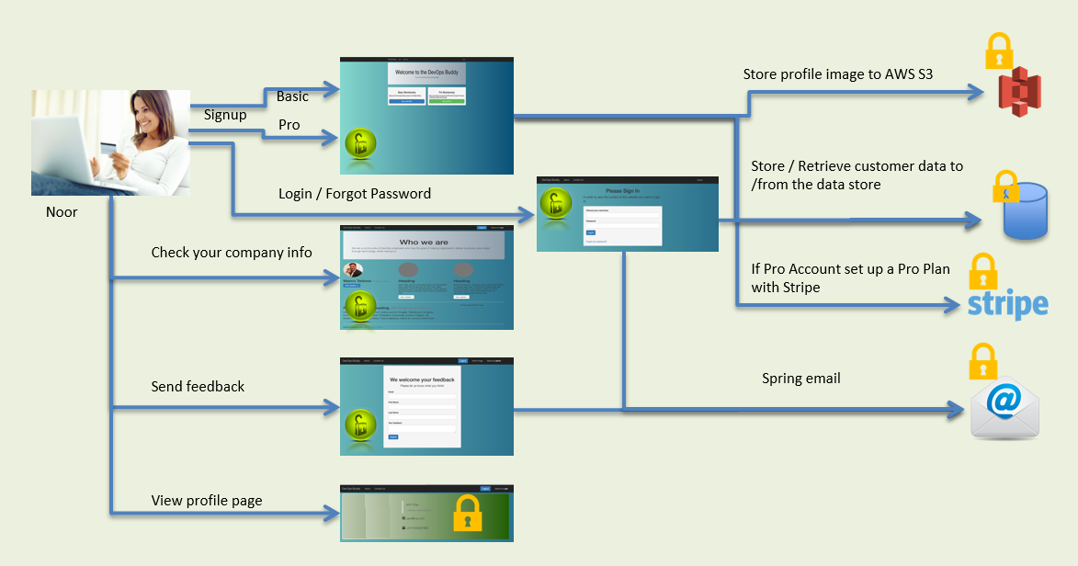

# Architecture Diagram

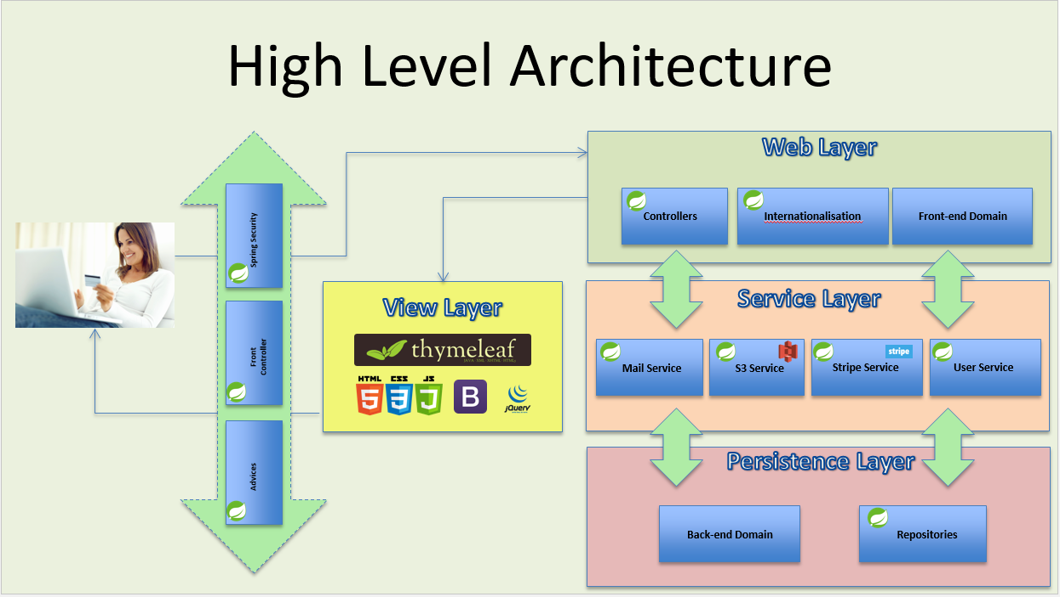

# Package Architecture

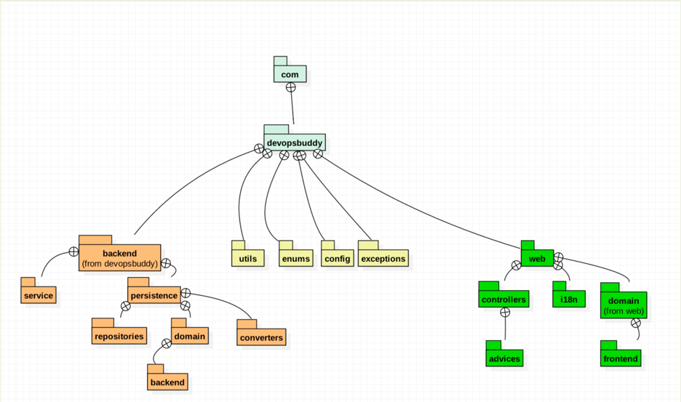

# Securing our website using Spring Boot Security

## Setup in memory Spring Boot authentication

## Pom.xml

* Added spring-boot-starter-security
* Added thymeleaf-extras-springsecurity4

## [config] SecurityConfig

* extends WebSecurityConfigurerAdapter
* @Autowired configureGlobal(AuthenticationManagerBuilder auth)
* @Override configure(HttpSecurity http)

## Navbar.html

Added Spring Expression Language (SPEL)

<**li th:if="${#authorization.expression('!isAuthenticated()')}"**>  
 <**a th:href="@{/login}" th:text="#{navbar.login.text}"** />  
</**li**>

## Setup Security Service

## Security Authentication Database model

## Application-dev.properties

* Added – Spring JPA (h2) properties

## DevelopmentConfig

* Added public ServletRegistrationBean h2ConsoleServletRegistration

## SecurityConfig

* Added "/console/**" to the list of permitAll

## Hibernate Entities [backend.persistence.domain.backend]

* Added Plan, User, Role, UserRole entities

## Added JPA repositories [backend.persistence.domain.repositories]

* Added PlanRepository, RoleRepository, UserRepository
* Added RepositoriesIntegrationTest

$ git merge userdetails

Updating dfc7243..40e9aa2

Fast-forward

.../persistence/domain/backend/Authority.java | 20 +++++++++++

.../backend/persistence/domain/backend/Role.java | 2 +-

.../backend/persistence/domain/backend/User.java | 37 ++++++++++++++++---

.../persistence/domain/backend/UserRole.java | 30 ++++++++++------

.../persistence/repositories/UserRepository.java | 7 ++++

.../backend/service/UserSecurityService.java | 32 +++++++++++++++++

.../com/devopsbuddy/config/SecurityConfig.java | 8 +++--

.../integration/RepositoriesIntegrationTest.java | 41 +++++++++++++---------

8 files changed, 140 insertions(+), 37 deletions(-)

$ git merge bcrypt

Updating 40e9aa2..ae7c38b

Fast-forward

.../java/com/devopsbuddy/backend/service/UserService.java | 7 +++++++

src/main/java/com/devopsbuddy/config/SecurityConfig.java | 14 +++++++++++++-

$ git merge indexes

Updating ae7c38b..ee60f84

Fast-forward

src/main/java/com/devopsbuddy/DevopsbuddyApplication.java | 5 ++++-

.../devopsbuddy/backend/persistence/domain/backend/User.java | 2 ++

src/main/java/com/devopsbuddy/utils/UsersUtils.java | 6 +++---

.../test/integration/RepositoriesIntegrationTest.java | 10 ++++++++--

.../test/integration/UserServiceIntegrationTest.java | 8 +++++++-

$ git merge forgotpassword

Updating ee60f84..911b453

Fast-forward

src/main/java/com/devopsbuddy/DevopsbuddyApplication.java | 15 ++++++++++++---

.../java/com/devopsbuddy/config/ApplicationConfig.java | 2 ++

src/main/resources/env/application-common.properties | 3 +++

$ git merge forgotpassword

Updating 911b453..fd2b27b

Fast-forward

.../LocalDateTimeAttributeConverter.java | 21 ++++

.../domain/backend/PasswordResetToken.java | 113 +++++++++++++++++++++

.../backend/persistence/domain/backend/User.java | 15 +++

.../repositories/PasswordResetTokenRepository.java | 18 ++++

.../persistence/repositories/UserRepository.java | 16 +++

src/main/resources/application.properties | 3 +-

.../test/integration/AbstractIntegrationTest.java | 63 ++++++++++++

...est.java => UserRepositoryIntegrationTest.java} | 73 ++++++----

$ git merge forgotpassword

Updating fd2b27b..fc6856c

Fast-forward

.../repositories/PasswordResetTokenRepository.java | 1 +

.../persistence/repositories/UserRepository.java | 2 +

.../backend/service/PasswordResetTokenService.java | 73 ++++++++++++++++++++++

.../devopsbuddy/backend/service/UserService.java | 15 +++++

.../AbstractServiceIntegrationTest.java | 31 +++++++++

.../PasswordResetTokenServiceIntegrationTest.java | 55 ++++++++++++++++

.../integration/UserRepositoryIntegrationTest.java | 26 ++++----

.../integration/UserServiceIntegrationTest.java | 9 +--

Part 1 of email journey:

$ git merge forgotpassword

Updating 18afd91..2a734f9

Fast-forward

.../com/devopsbuddy/DevopsbuddyApplication.java | 5 +-

.../{web/i18n => backend/service}/I18NService.java | 2 +-

.../com/devopsbuddy/config/SecurityConfig.java | 4 +-

src/main/java/com/devopsbuddy/utils/UserUtils.java | 62 +++++++++++++++

.../java/com/devopsbuddy/utils/UsersUtils.java | 35 --------

.../controllers/ForgotMyPasswordController.java | 93 ++++++++++++++++++++++

src/main/resources/application.properties | 2 +-

src/main/resources/i18n/messages.properties | 13 ++-

.../templates/forgotmypassword/emailForm.html | 53 ++++++++++++

src/main/resources/templates/user/login.html | 1 +

.../devopsbuddy/DevopsbuddyApplicationTests.java | 2 +-

.../test/integration/AbstractIntegrationTest.java | 4 +-

.../AbstractServiceIntegrationTest.java | 4 +-

.../integration/UserRepositoryIntegrationTest.java | 6 --

.../integration/UserServiceIntegrationTest.java | 6 --

.../devopsbuddy/test/unit/UserUtilsUnitTest.java | 39 +++++++++

Email Journet part 2

$ git merge forgotpassword

Updating 736c8bd..f79aa23

Fast-forward

.../com/devopsbuddy/config/SecurityConfig.java | 3 +-

.../controllers/ForgotMyPasswordController.java | 98 ++++++++++++++++++++++

src/main/resources/i18n/messages.properties | 5 +-

.../templates/forgotmypassword/changePassword.html | 67 +++++++++++++++

# User Creation Journey

## High Level picture on Filling Form

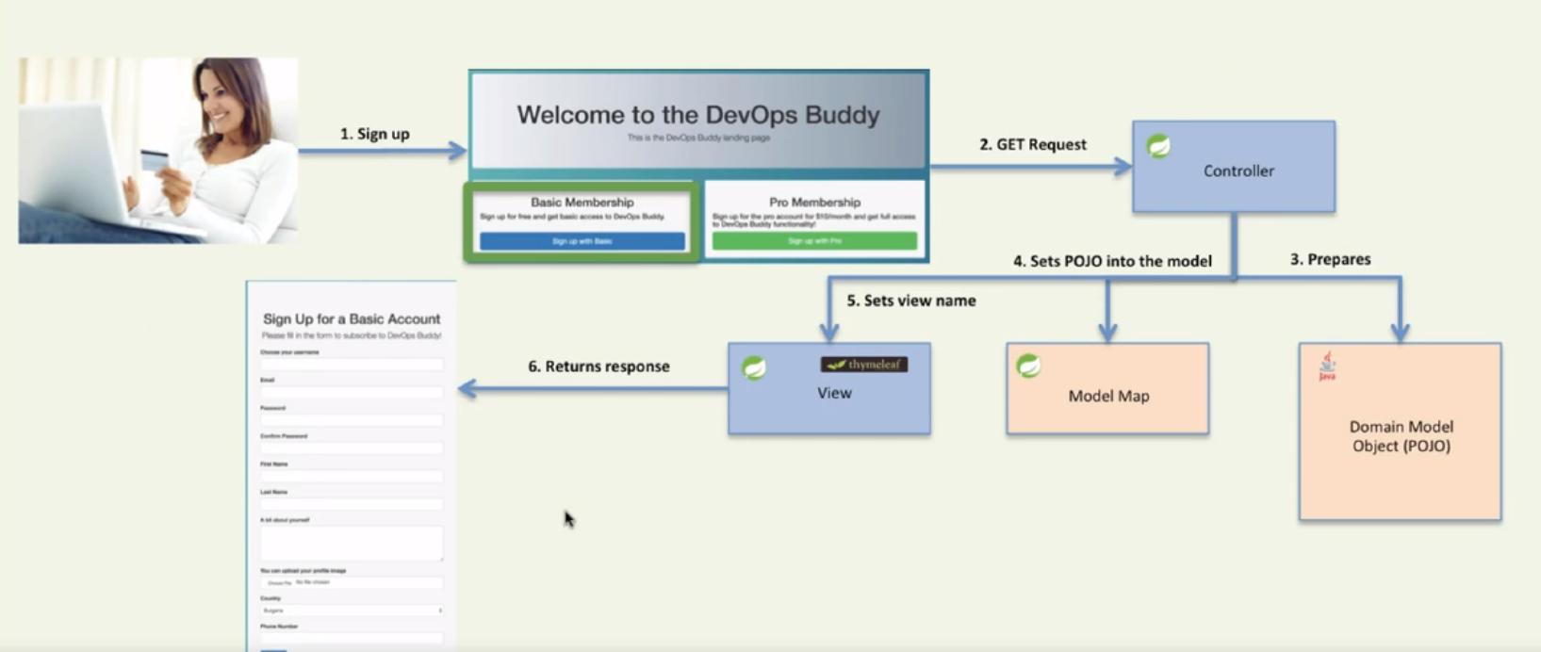

$ git merge useraccount

Updating d274189..bbe3707

Fast-forward

pom.xml | 25 +++-

src/main/java/com/devopsbuddy/utils/UserUtils.java | 16 +++

.../web/domain/frontend/BasicAccountPayload.java | 149 +++++++++++++++++++++

src/main/resources/Docs/Architecture Design.docx | Bin 1288723 -> 1616077 bytes

src/main/resources/Docs/~$chitecture Design.docx | Bin 0 -> 162 bytes

.../devopsbuddy/test/unit/UserUtilsUnitTest.java | 31 ++++-

6 files changed, 212 insertions(+), 9 deletions(-)

create mode 100644 src/main/java/com/devopsbuddy/web/domain/frontend/BasicAccountPayload.java

create mode 100644 src/main/resources/Docs/~$chitecture Design.docx

bootstrap container and grid systems

$ git merge useraccount

Updating bbe3707..f716334

Fast-forward

.../com/devopsbuddy/config/SecurityConfig.java | 4 +-

.../web/controllers/SignupController.java | 51 ++++++++

.../web/domain/frontend/ProAccountPayload.java | 45 +++++++

src/main/resources/i18n/messages.properties | 13 +-

src/main/resources/static/css/styles.css | 7 +

src/main/resources/templates/index.html | 38 +++++-

.../resources/templates/registration/signup.html | 141 +++++++++++++++++++++

7 files changed, 290 insertions(+), 9 deletions(-)

create mode 100644 src/main/java/com/devopsbuddy/web/controllers/SignupController.java

create mode 100644 src/main/java/com/devopsbuddy/web/domain/frontend/ProAccountPayload.java

create mode 100644 src/main/resources/templates/registration/signup.html

## Handling the Post Request

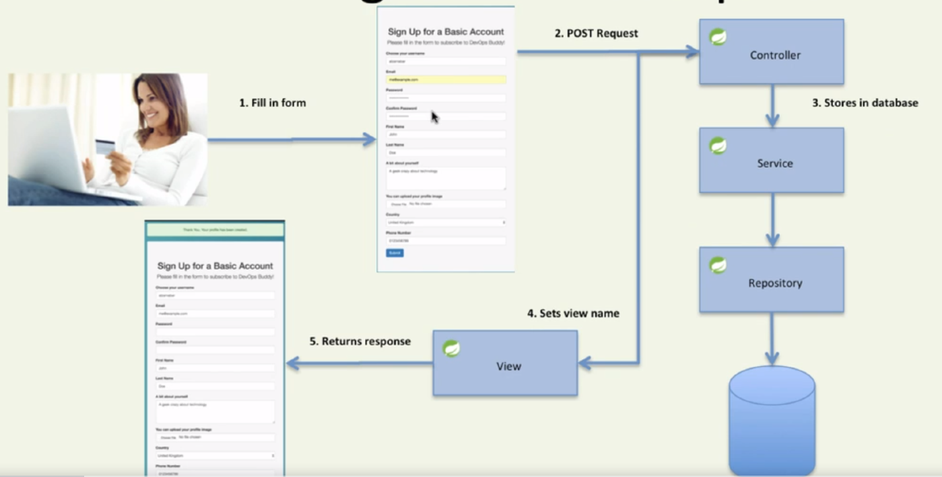

Post

$ git merge useraccount

Updating f716334..e467de8

Fast-forward

.../com/devopsbuddy/DevopsbuddyApplication.java | 8 ++

.../devopsbuddy/backend/service/PlanService.java | 47 ++++++++

.../devopsbuddy/backend/service/UserService.java | 18 +++

.../web/controllers/SignupController.java | 123 ++++++++++++++++++++-

src/main/resources/Docs/Architecture Design.docx | Bin 1616077 -> 1895842 bytes

src/main/resources/Docs/~$chitecture Design.docx | Bin 162 -> 0 bytes

src/main/resources/templates/common/navbar.html | 2 +-

7 files changed, 193 insertions(+), 5 deletions(-)

create mode 100644 src/main/java/com/devopsbuddy/backend/service/PlanService.java

delete mode 100644 src/main/resources/Docs/~$chitecture Design.docx

## Image Upload

$ git merge s3

Updating e467de8..e03405c

Fast-forward

.../devopsbuddy/web/controllers/SignupController.java | 16 ++++++++++++++++

src/main/resources/i18n/messages.properties | 3 ++-

src/main/resources/templates/registration/signup.html | 5 +++++

3 files changed, 23 insertions(+), 1 deletion(-)

$ git merge s3

Updating 651fe78..925928e

Fast-forward

pom.xml | 13 ++

.../com/devopsbuddy/backend/service/S3Service.java | 160 +++++++++++++++++++++

.../com/devopsbuddy/config/ApplicationConfig.java | 18 +++

.../web/controllers/SignupController.java | 8 +-

.../resources/env/application-common.properties | 8 +-

5 files changed, 203 insertions(+), 4 deletions(-)

create mode 100644 src/main/java/com/devopsbuddy/backend/service/S3Service.java